Aqua Spatia

Safou

**Problem Statement:**

Imagine constructing a container using blocks of varying heights placed in a straight line. When water is poured, it collects in the gaps between the blocks, limited by the heights of the blocks around it. Your task is to calculate the total amount of water that can be stored in the spaces between these blocks.

**Input:** You are given a T test case where each one contains:

* The first line contains an integer n, the number of blocks.
* The second line contains n space-separated integers representing the heights of the blocks in the array arr[].

**Output:**

* For each test case, output a single integer on a new line representing the amount of water that can be stored between the blocks. At the end, print the total amount of water stored in all the containers.

**Example 1:**

Input :

6

3 0 0 2 0 4

Output : 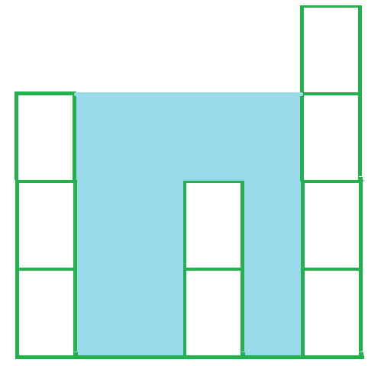

10

**Example 2:**

Input:

4

7 4 0 9

Output:

10

Explanation:

Water trapped by above

block of height 4 is 3 units and above

block of height 0 is 7 units. So,

the total unit of water trapped is 10 units.

**Flag:**

For the flag, you will need to calculate the total amount of water stored in all the containers. The result should be displayed in the following **format**:

A total of {total_volume} units of water have been collected.